
NIU Design and Construction Standards
Division 12 9300 – Site Furnishings
March 2012, Draft 00
12 9300 – Site Furnishings
PART 1.
1.01
GENERAL
This section includes:
A.
B.
C.
D.
E.
F.
G.
H.
Div 12 9313
Div 12 9323
Div 12 9333
Div 12 9343
Div 12 9343
Site Bollards
Bicycle Racks and Loops
Waste Receptacles, Recycle Receptacles and Ash Urns Manufactured Planters (to be added)
Site Seating
Site Tables
Post and Chain
Div 10 7343 Bus Shelters
1.02
Installation locations for products under this standard shall be approved by A&E Services
PART 2.
2.01
PRODUCTS
Bicycle Racks and Loops
A. Single unit Loops
1. Manufacturer: Wabash Valley Manufacturing, Inc. www.wabashvalley.com
a).
b).
Model BL100N, 36”, Black (Figure 5)
In ground
B. Multiple unit racks
1. Manufacturer: Cora Bike Rack, Inc. www.cora.com
a).
b).
c).
Cora Expo ‘W’ Series Bicycle Rack (Figure 6) Length to be determined by A&E Services Surface mount
2.02
Waste and Recycle Receptacles
- Manufacturer: Victor Stanley, Inc. www.victorstanley.com
- Supplier: Howard L. White & Associates, Buffalo Grove, IL http://www.howardlwhite.com/
1. Waste Receptacles: (Figure 2)
Site Furnishings Div 12 9300 Page 1 of 7

NIU Design and Construction Standards
Division 12 9300 – Site Furnishings
a).
b).
c).
d).
Model S-42, Ironsites, Bethesda Series 36 Gallon (136 Liter) PVC liner Powder coated, Black
S-2 Dome top, powder coated, Black
2.
Recycle Receptacles: (Figure 1)
a).
b).
c).
d).
e).
Model S-42, Ironsites, Bethesda Series 36 Gallon (136 Liter) PVC liner Powder coated, Blue
S-2 Dome top, powder coated, Blue
Recycle decal produced and applied by NIU Media Services
3.
Ash Urns (Figure 3, 4)
a).
b).
c).
d).
Model S-20, Ironsites, Bethesda Series 6 Gallon
Powder coated, Black
Standard stainless-steel ashtray
2.03
2.04
Manufactured Planters (to be added)
Site Seating
A.
Manufacturer: Landscapeforms, Inc. www.landscapeforms.com
1. Benches, (backed) (Figure 3)
a).
b).
c).
d).
e).
f).
Scarborough
Backed, horizontal strap seat style 28”x 34”x 72”
28”x 34”x 24”
Surface mount Powder coat, Black
2.
Benches, (backless)
a).
b).
c).
d).
e).
Scarborough
Backless, horizontal strap seat style 28”x 34”x72”
Surface mount Powder coat, Black
B.
Other style selections, color or bench length must be submitted in writing, to A&E Services.
2.05
Site Tables
A. Manufacturer: Landscapeforms, Inc. www.landscapeforms.com
1. Carousel (Figure 7)
Site Furnishings Div 12 9300 Page 2 of 7

NIU Design and Construction Standards
Division 12 9300 – Site Furnishings
a).
b).
c).
Table top: Steelhead Perforated
Seat: Perforated (seat pattern must match table top pattern) Number of seats per table unit to be selected by Campus Planning Coordinator.
Surface mount
d).
B. Other style selections, color or bench length must be submitted in writing, to A&E Services.
2.06
Site Bollards
A. Manufacturers:
1. Reliance Foundry Co. Ltd. www.reliance-foundry.com/
a).
Cast Iron model R-7589, Black (Figure 8)
B. Other style selections, sizes or colors must be submitted in writing, to A&E Services
2.07
Post and Chain
A. Post and Chain shall be manufactured using:
- 2 inch diameter SS40 gauge galvanized pipe with Black vinyl coating
- Black vinyl coated Acorn cap
- Single brace band and end posts
- Double brace bands on line posts
B. Acorn cap and galvanized pipe suppliers:
- Merchant Metals - http://www.merchantsmetals.com/
- Master Halco, Inc.- http://www.masterhalco.com/
- Stephens Pipe and Steel - http://www.spsfence.com/
2.08
Bus Shelters
A. Bus Shelters as manufactured by:
1. Brasco International - http://brasco.com/
a).
Model: Slimline Series
1). 8’ X 6’, (Figure 9)
2). 12’ X 6’(Figure 10)
3). Example dimensional drawing (Figure 11)
Dark bronze anodized aluminum structure
¼” Clear tempered glass
Site Furnishings
b).
c).
Div 12 9300 Page 3 of 7

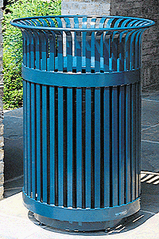
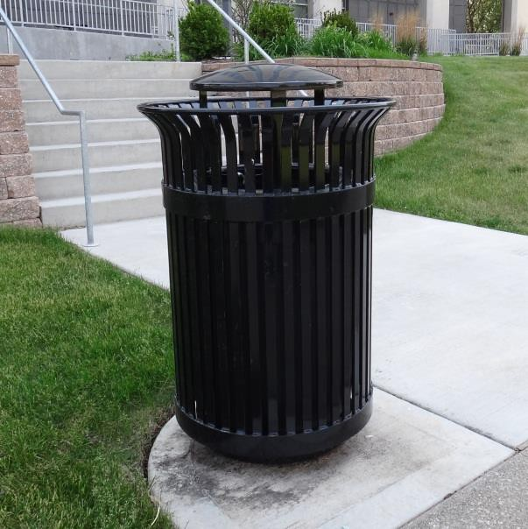
NIU Design and Construction Standards
Division 12 9300 – Site Furnishings
- White dome roof with fascia/gutter system
- Full length aluminum wall mounted bench and backrest
B. Other style selections, sizes or colors must be submitted in writing, to A&E Services
PART 3. EXECUTION
3.01
Installation
A.
Benches, Tables, Trash and Recycle Receptacles and Ash Urns:
1. Installed on concrete slab (available sidewalk or area determined by A&E Services), using corrosion resistant cinch anchors.
B.
Bicycle Loops installed per Manufacturer’s recommendations.
C.
Bicycle Racks installed per Manufacturer’s recommendations.
D.
Bollards installed per Manufacturer’s recommendations.
E.
Post and chain installed as directed by A&E Services
F.
Bus shelters installed per Manufacturer’s recommendations.
Photographs and Drawings:
Site Furnishings Div 12 9300
Page 4 of 7
Figure 2 – Victor Stanley Model S-42 Waste Receptacle With dome
Figure 1 – Victor Stanley Model S-42 Recycle Receptacle Without dome

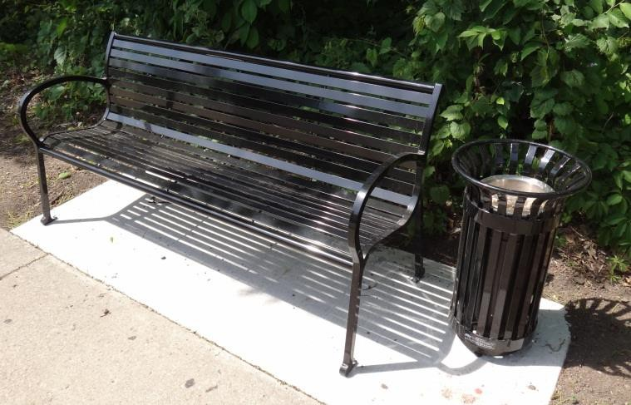
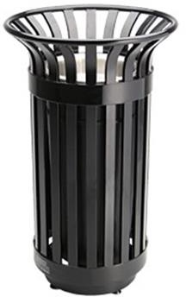
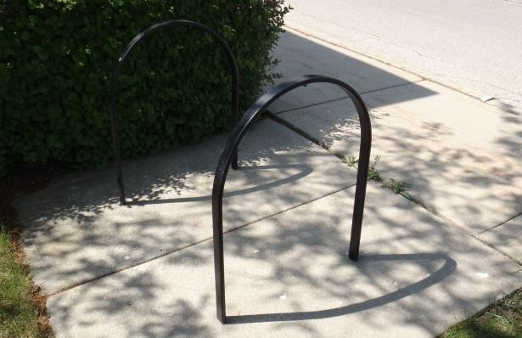
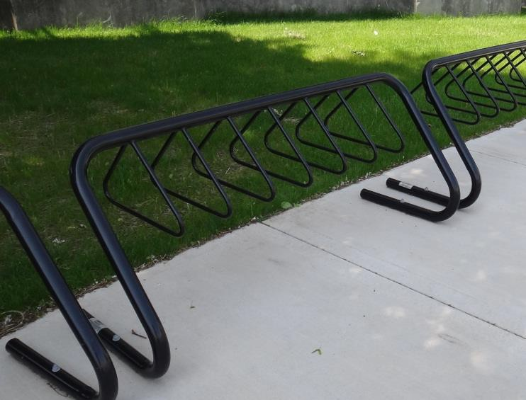
NIU Design and Construction Standards
Division 12 9300 – Site Furnishings
Site Furnishings Div 12 9300 Page 5 of 7
Figure 6 – Cora Bike Rack, Cora Expo ‘W’ Series
Figure 5 – Wabash Valley, Model BL100N

Figure 4 – Victor Stanley Model S-20 Ash Urn
Figure 3 – Landscapeforms Scarbough Model

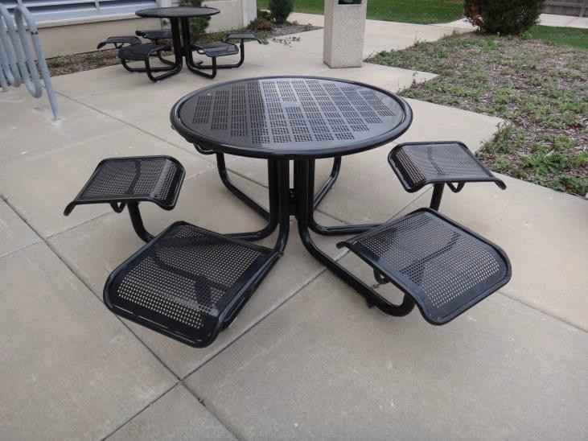
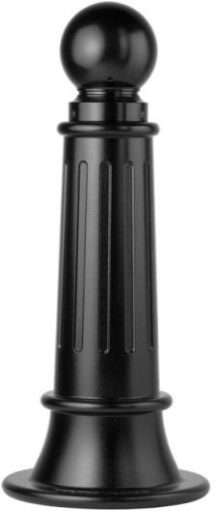
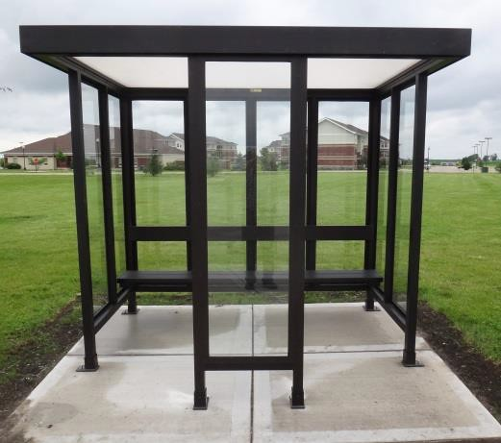
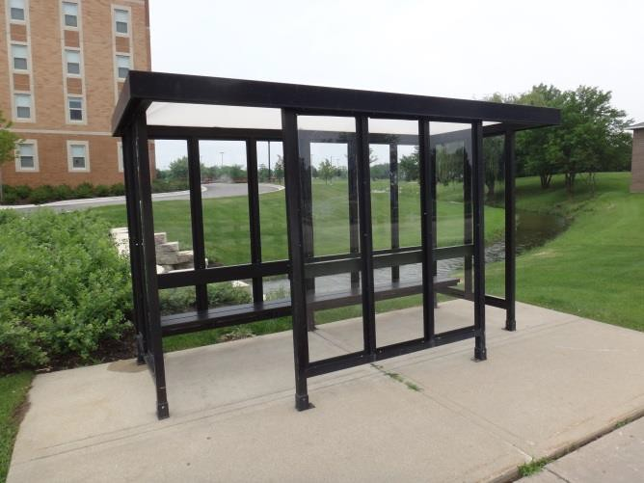
NIU Design and Construction Standards
Division 12 9300 – Site Furnishings
Site Furnishings Div 12 9300 Page 6 of 7
Figure 10 –
Brasco Slimline, 12 X 6
Figure 9 –
Brasco Slimline, 8 X 6
Figure 8 – Reliance Foundry Co., Model R-7589
Figure 7 – Landscapeforms, Carousel Model

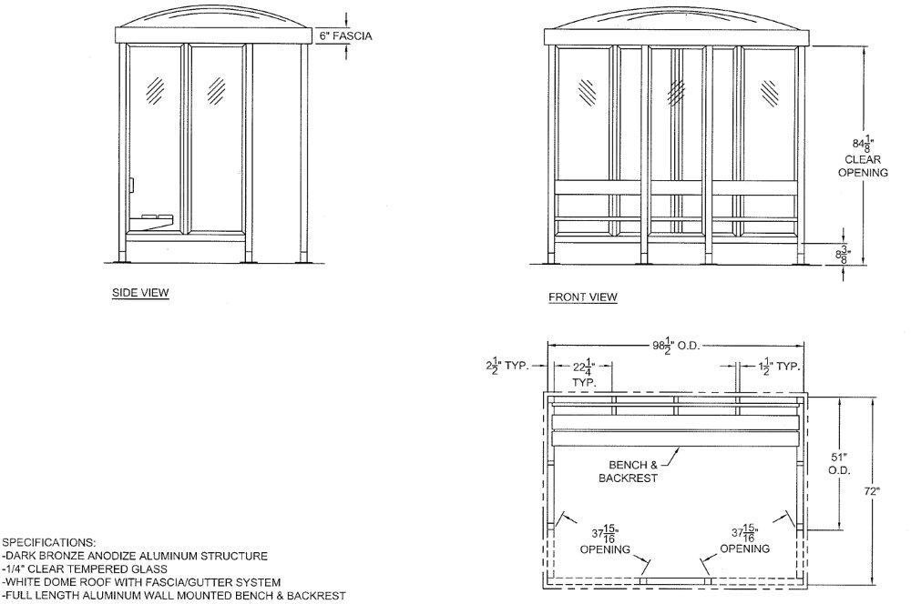
NIU Design and Construction Standards
Division 12 9300 – Site Furnishings
Figure 11
Example Dimensional Drawing
End of Division 12 9300
This section of the NIU Design and Construction Standards establishes minimum
requirements only. It should not be used as a complete specification.
Site Furnishings Div 12 9300 Page 7 of 7

